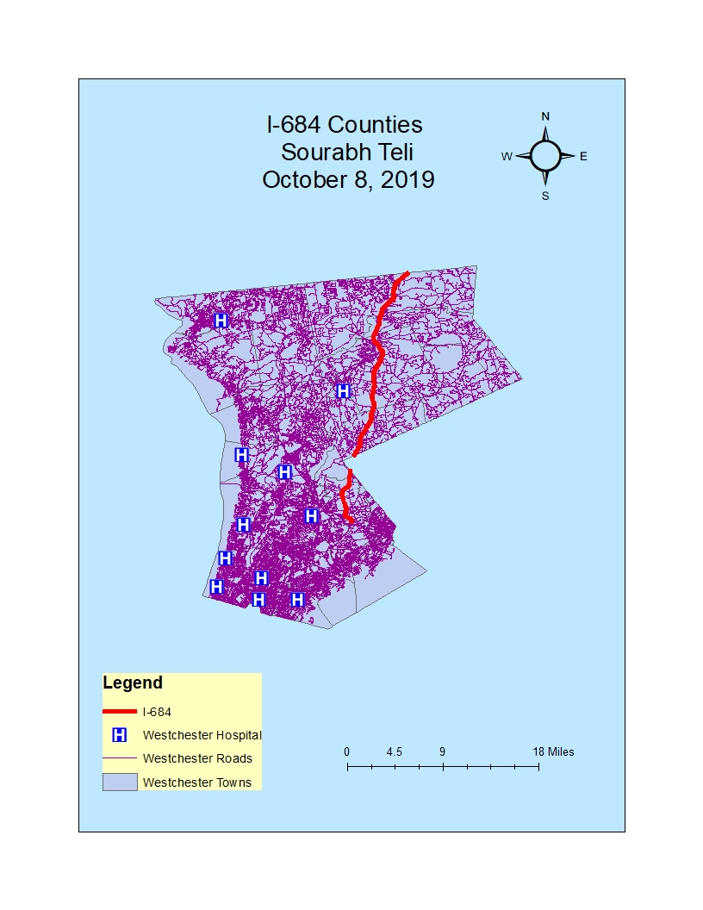

MAP 01:- Westchester I-684

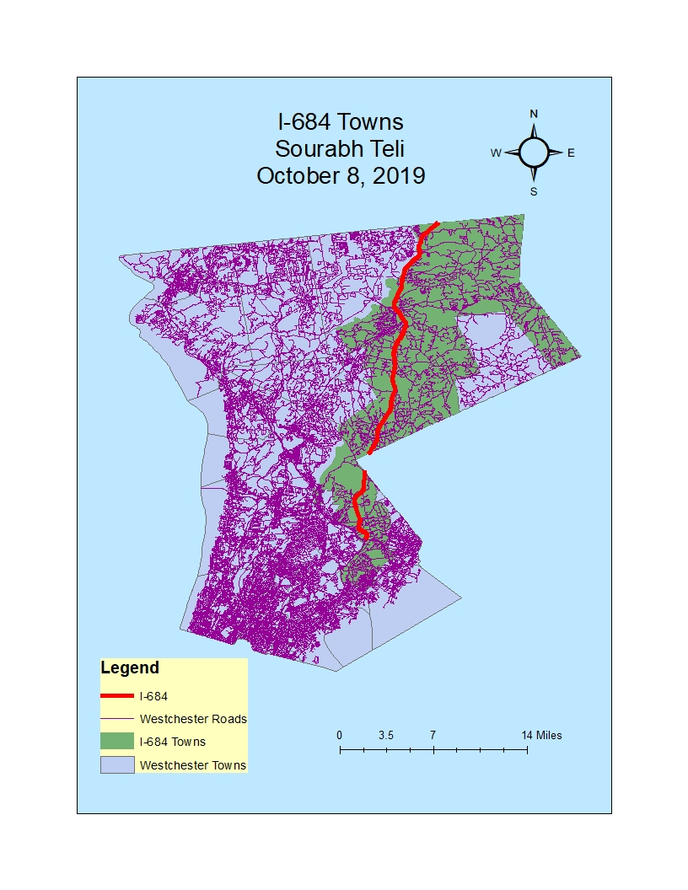

MAP-02:- I684 Towns

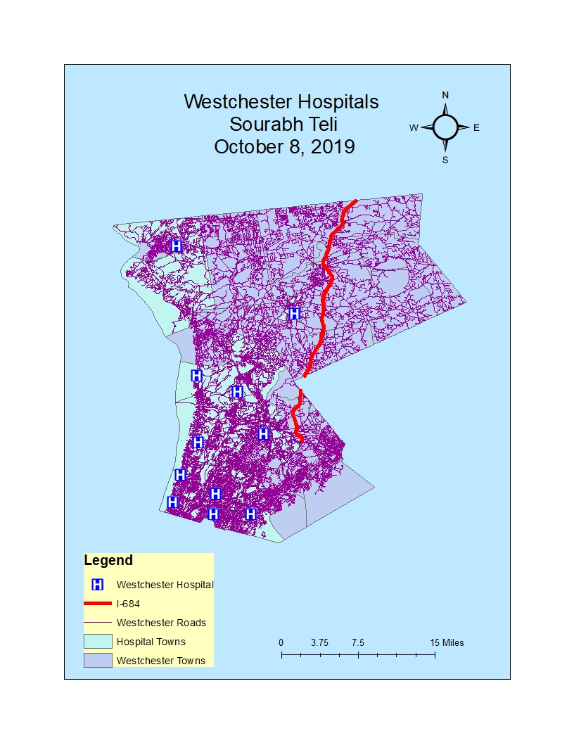

MAP 03:- WESTCHESTER HOSPITALS

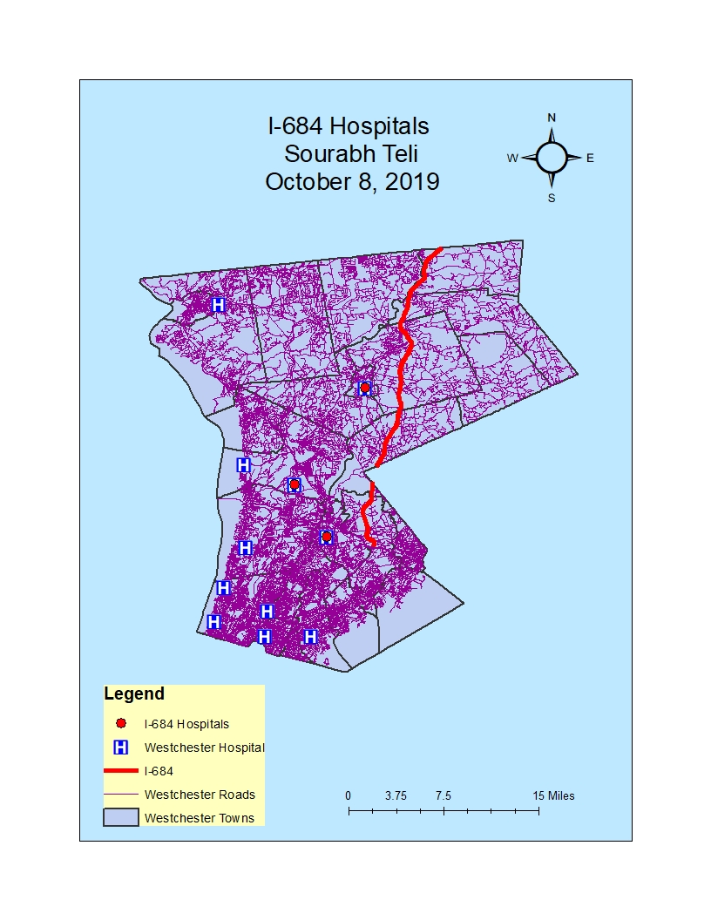

MAP 04:- I-684 HOSPITALS

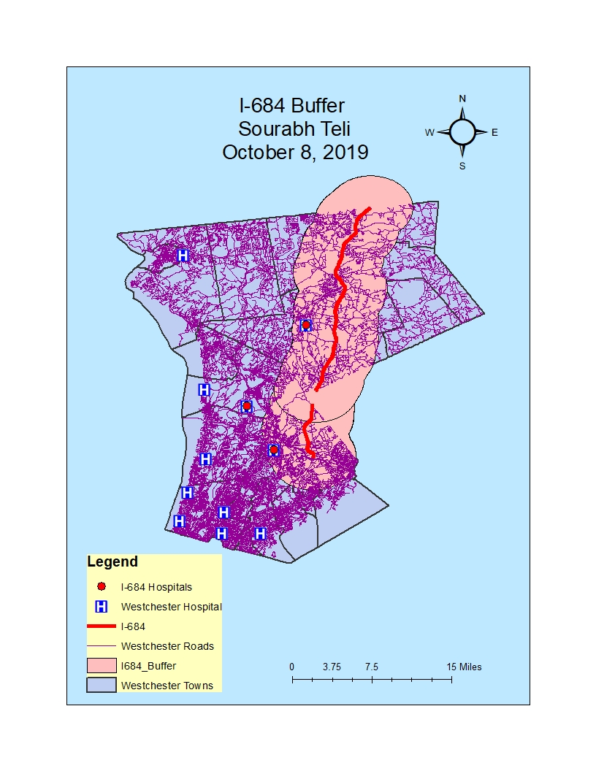

MAP 05:- I-684 BUFFER